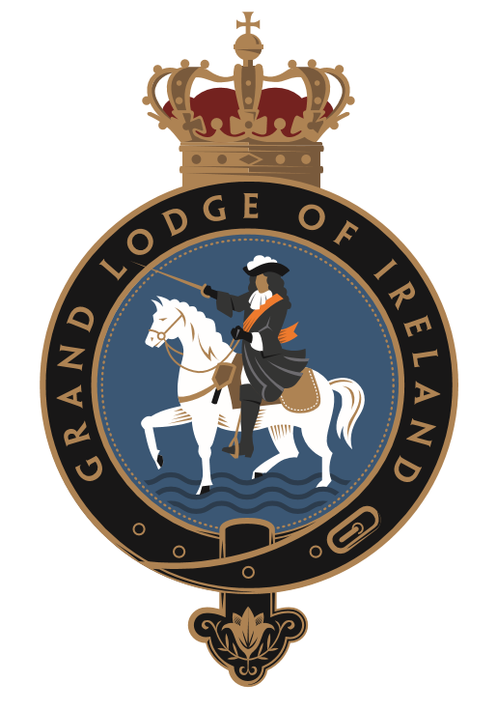
Grand Orange Lodge of Ireland
Community Awards 2025

NOMINATION FORM
BEST NEW BANNER 2025

Name/No of Lodge:

Name & Address of Lodge Secretary:

Phone No:

Email:

Lodge Website:

Nominated by (if different from the above Lodge):

Address:

Phone:

Email:

When was the new banner unfurled? Please note, this category is for banners unfurled between January 2024 to December 2024.

Name and address of your banner painter:

Summary of reasons for the design of your Banner, front, and rear (use separate sheet if necessary).
Please note – a clear photo of the front and back of the banner MUST be provided with every nomination in this category. We would also be obliged if you could email photographs in jpeg format to ocawards2025@goli.org.uk

Summary reasons for the design of your Banner, front, and rear (continued)
(Use separate sheet if necessary).

Have you included copies of some or all of the following:

Newspaper cuttings
xX
Documentation of any other nature
Confirmation of an independent contact
Anything else which may be helpful to the application

Please ensure this form is completed as fully as possible.
Make sure all supporting evidence is provided, as the Judges will use this form solely during the judging process.

If you require any further information relating to the Orange Community Awards or assistance completing this form, please contact us at either of the following.

Tel: 028 9070 1122
Email: ocawards2025@goli.org.uk

Return completed Nomination Form and all supporting documentation to:

Grand Orange Lodge of Ireland
Schomberg House
368 Cregagh Road
Belfast
BT6 9EY

Email: ocawards2025@goli.org.uk

CLOSING DATE FOR NOMINATIONS: Friday 7th February 2024

THANK YOU FOR YOUR NOMINATION!

